**Smart Baby Warmer (INTELI-NICU) Platform**

**Data accusation**

* In Application we are using Bluetooth BLE for Communicating to hardware.
* Every BLE Device Have own mac id is a unique, whenever we connect device to hardware we need mac id for connection, after site installation we get MACID from the cloud.
* First time MACID automatically come ,later will change from the cloud & sync to device side.

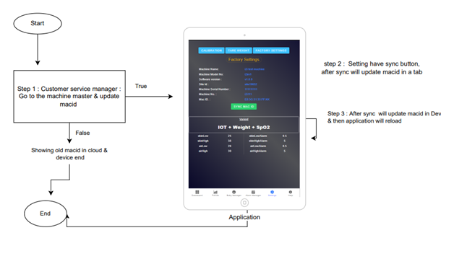

Here is describe how device fetch MACID from the cloud

* Application Hand -shaking to hardware, ones done connection then hardware pull data to device in every 1 sec of interval.
* Below Is the String which is hardware pull

**T1,T2,T3,heater ,mode**

{"DID":"SBWXXX","MID":"201","AT":"42.8","BT":"30.3","PT":"33.4","HT":"0","M":"3"}

**hardware alerts**

{"DID": "SBWXXX","MID":"440","AL" : "['0', '1', '1', '0', '0', '0', '0', '0', '0', '0', '0', '0', '0', '0', '0', '0', '0']"}

* Device pull data on cloud every one minute of interval, if internet is available then send cloud otherwise store in device later will send to cloud hence internet come.

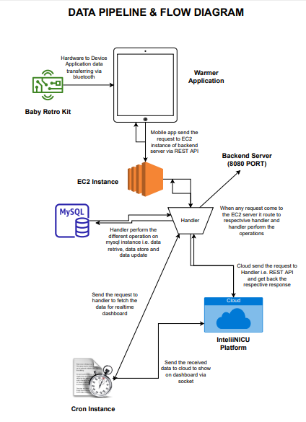

Data Pipeline Diagram